Profile of HASI

Name and address of the NGO

Homeland Association for Social Improvement (HASI)

Address:

Head Office:
Oskhali Bazar,
Hatiya, Noakhali
Phone: 01711-478457
03224-56061

Liaison Office:
House # 661, Road # 14
Baitul Aman Housing Society
Uttar Adabar. Mohammedpur
Dhaka- 1207
Phone: 02-58153450

Contact person
Advocate Akram Hossain Rumi
Executive Director
Mobile: 01711478457
Email: akramedhasi@yahoo.com

Date of Establishment: May 25, 1996

Legal Status
- Homeland Association for Social (HASI) is registered as a Non-Govt. Organization (NGO) with the Social Welfare Department, Govt. of Bangladesh, Reg. No. NOA-478, Dated: 12/10/1998.

- Homeland Association for Social Improvement (HASI) is registered with NGO Affairs Bureau, government of Bangladesh under Foreign Donations (Voluntary activities) Regulation Rules, 1978. Reg no. 1499, Dated: 29/03/2000.

Geographical Coverage
District |  | Upazilla
Noakhali |  | Hatiya & Suborno Char & Kabir Hat
Chandpur |  | Hajigonj
Kishoregonj |  | Bhairab
Rangamati |  | Khawkhali

Total Staff : Project and Support
Regular | Project | Support | Total
12 | 32 | 03 | 47

Background of HASI
Homeland Association for Social Improvement (HASI) is a non-profit and non-government organization started working in remote coastal island Hatiya of Noakhali District. Since 1996 HASI came to light by some highly motivated people with a view to socio-economic uplift of the poor, landless and disadvantaged people of Hatiya Inland. Since its inception the organization has been working for institution building of the target group with a special emphasis on distressed women, girls and children and occupational groups. The main thrust of HASI’s program is to organize the rural poor women and men, living in vulnerable locations and exposed to different disasters, into

The socio-economic situation of the said working area is very odd where the poverty, illiteracy, unemployment rate lack of adopting new technologies in agriculture, Health hazard's, occurrence of natural disaster events are much higher than that of other area of the country. Other than this the leadership, decision making process and resource constraints are considered major problems in areas.

With extensive Socio-Economic baseline survey and analysis of secondary data HASI identified following crisis before started its integrated activities in Hatiya Island-which initially target area for providing as an extensive and integrated program:

- Poor socio-economic background and lack of income generating activities;
- Poor savings rate and employment opportunity’
- High malnutrition and child mother mortality rate;
- Research and Study;
- Poor sanitation and hygiene;
- Lack of safe drinking water supply;
- Lack of environmental consciousness;
- Lack of preparedness for mitigating the impacts of disaster
- Lack of leadership and women empowerment;
- Violation of human rights.
- Social injustice to divorced, widow, orphan, and physical and mental handicap and good governess;
- Lack of scientific agricultural and irrigation system;
- Lack of social mobilization & people participatory approach;
- Lack of contributory co- operative attitude to meet up need based socio- economic crisis.
- Lack of disaster preparedness and management planning.
- Risk of STD, HIV/AIDS

Finding these odds and evils with an extensive baseline survey and secondary data assessment HASI started its function with a group of highly motivated and self convinced dedicated group to uplift the socio-economic status of the mass community of the island with a cumulative effort. It welcomes all source of co-operation of thinking and monetary support from both home and abroad to mitigate the identified crisis co-opting the mission and vision of HASI.

Later on HASI gradually decided and capable to extend its service with the adjacent district of the initially selected working area. With this view, In course of time HASI expand its program with assistant from government in other donor in Chandpur, Kishorgonj Rangamati and Noakhali district subsequently. HASI’s attempt for sustainable development, improved disaster preparedness and social transformation is continuing for expanding.

Organization Vision:
HASI dreams a society where without any discrimination and division of sex, caste, color. The people will enjoy full dignity and enable themselves to be involved and participate in the main stream development for sustainability and empowerment.

Organization Mission:
Make significant contribution to the optimum changes of the target people, living in the vulnerable locations , and provide them demand driven services by promoting their efficient participation, Creating environment for gender balanced interaction, mobilizing local resources, social commitment, advocacy and capacity building of the poor people that lead them to promote their self-reliant sustainable living in the family and social life with a special emphasis on participatory and contributory approach.

Organization Goal:
To change the socio-economic status of the poor people vulnerable to disaster and climate shocks, especially the disadvantaged women and children including physically disabled for better livelihood to promote and extend the socio-economic status in a considerable enlistment.

Beneficiaries:
HASI identified its target beneficiaries of the society as poor, disaster prone, landless and under privileged men, women and children of different communities and occupation to assist them the poverty eradication and self-development.

Objective of the Organization
Specific objective :
To uplift the socio-economic status of the target people of the catchments area with a special emphasis on participatory and sustainable development program.

- Detail Objectives:
- To mobilize and organize the disadvantaged poor people especially destitute women.
- To impart functional /non-function formal education and training to the illiterate women and adolescent girl to make them self-reliant.
- To institutionalize micro/macro credit program for the disadvantaged people for their socio-economic emancipation and poverty alleviation by undertaking sustainable income generating activities.
- To initiate micro entrepreneurship through credit program.
- To impart human and skill development training to the group members for efficiency, capacity building and behavioral change.
- To provide package of soft and hardware support to the distressed and disadvantage people about health, nutrition, water aid and sanitation.
- To reduce fertility rate in the area through MCH based family planning program.
- To undertake social forestry and sustainable agriculture in the area for environmental protection and ecological balance.
- To rehabilitate the people with disability & HIV/AIDS positive in the community through CBR.
- To reduce human rights violation by practicing good government in different tier.
- To undertake disaster preparedness, rescue and rehabilitation program within the working area.
- To development linkages with relevant government, national and international development agencies for wider support and co-operatives.
- To work closely with government, NGOs and relevant institutions at the local and national level for more efficient and responsive disaster preparedness, including early warning systems and mitigation strategies

Past experience implementing different development project / program and provided support to the beneficiaries till to date shown bellow :
Sl# | Name of the program or project / program | # of beneficiaries received support till to date | Donors name
01 | Non format primary  education (NEPE) | 1590 | BRAC-ESP, Proshika, CNDN
02 | Removing Learners through conducting adult literacy | 900 | DNFE
03 | Community development and arsenic mitigation project. | 7300 | BAMAWSP, DPHE
04 | Post literacy and continuing  education for human  development (PLCEHD-I) | 9000 | BNFE, World Bank & SDC
05 | Disable development program | 560 | CDD, NDDF, NFOWD,  Inter-life- BD
06 | Fishermen livelihood  development project | 1400 | GNAEP-DANIDA
07 | Destitute women development project | 200 | GNAEP-DANIDA
08 | Sustainable extension through union Parishad | 213 | GNAEP-DANIDA
09 | Rural Housing Loan program | 75 | Bangladesh Bank
10 | Horticulture and Nutrition  development project for Islander (HNDPI) | 1082 | CARE-LIFT
11 | Char development & Settlement  project-III (CDSP-III) | 1414 | Netherlands Embassy, BRAC
12 | SHOUHARDO Project(Community Capacity building for disaster management) | 6894 | CARE-Bangladesh
13 | Consecutive Vaccination Program for livestock development | 1100 | GNAEP-DANIDA
14 | Micro Credit for Poverty reduction. | 2189 | Own, CODEC, BRAC-NCU
HASI’s Disaster Management Programme

HASI’s experience in emergencies has grown considerably over the last 15 years, and we have responded quickly and effectively to numerous recent large-scale humanitarian disasters with three main strands: emergency response, rehabilitation and disaster risk reduction. Within HASI, the highly experienced Team acts as a central resource providing support to our disaster management works to improve the quality and impact of their work.
Disaster management is now one of the organization’s key areas of focus. HASI has a risk reduction unit dedicated to disaster management and also has experience in carrying out various disaster preparedness/risk reduction and emergency response programmes. The Risk Reduction unit, under the long –term development programme, aims to reduce vulnerability of the poor and marginalized so that their lives and livelihoods are more secure. The work of this unit facilitates processes by which poor and marginalized people can analyses disaster related vulnerabilities and their causes, and identify actions to better cope with the effects of disasters.

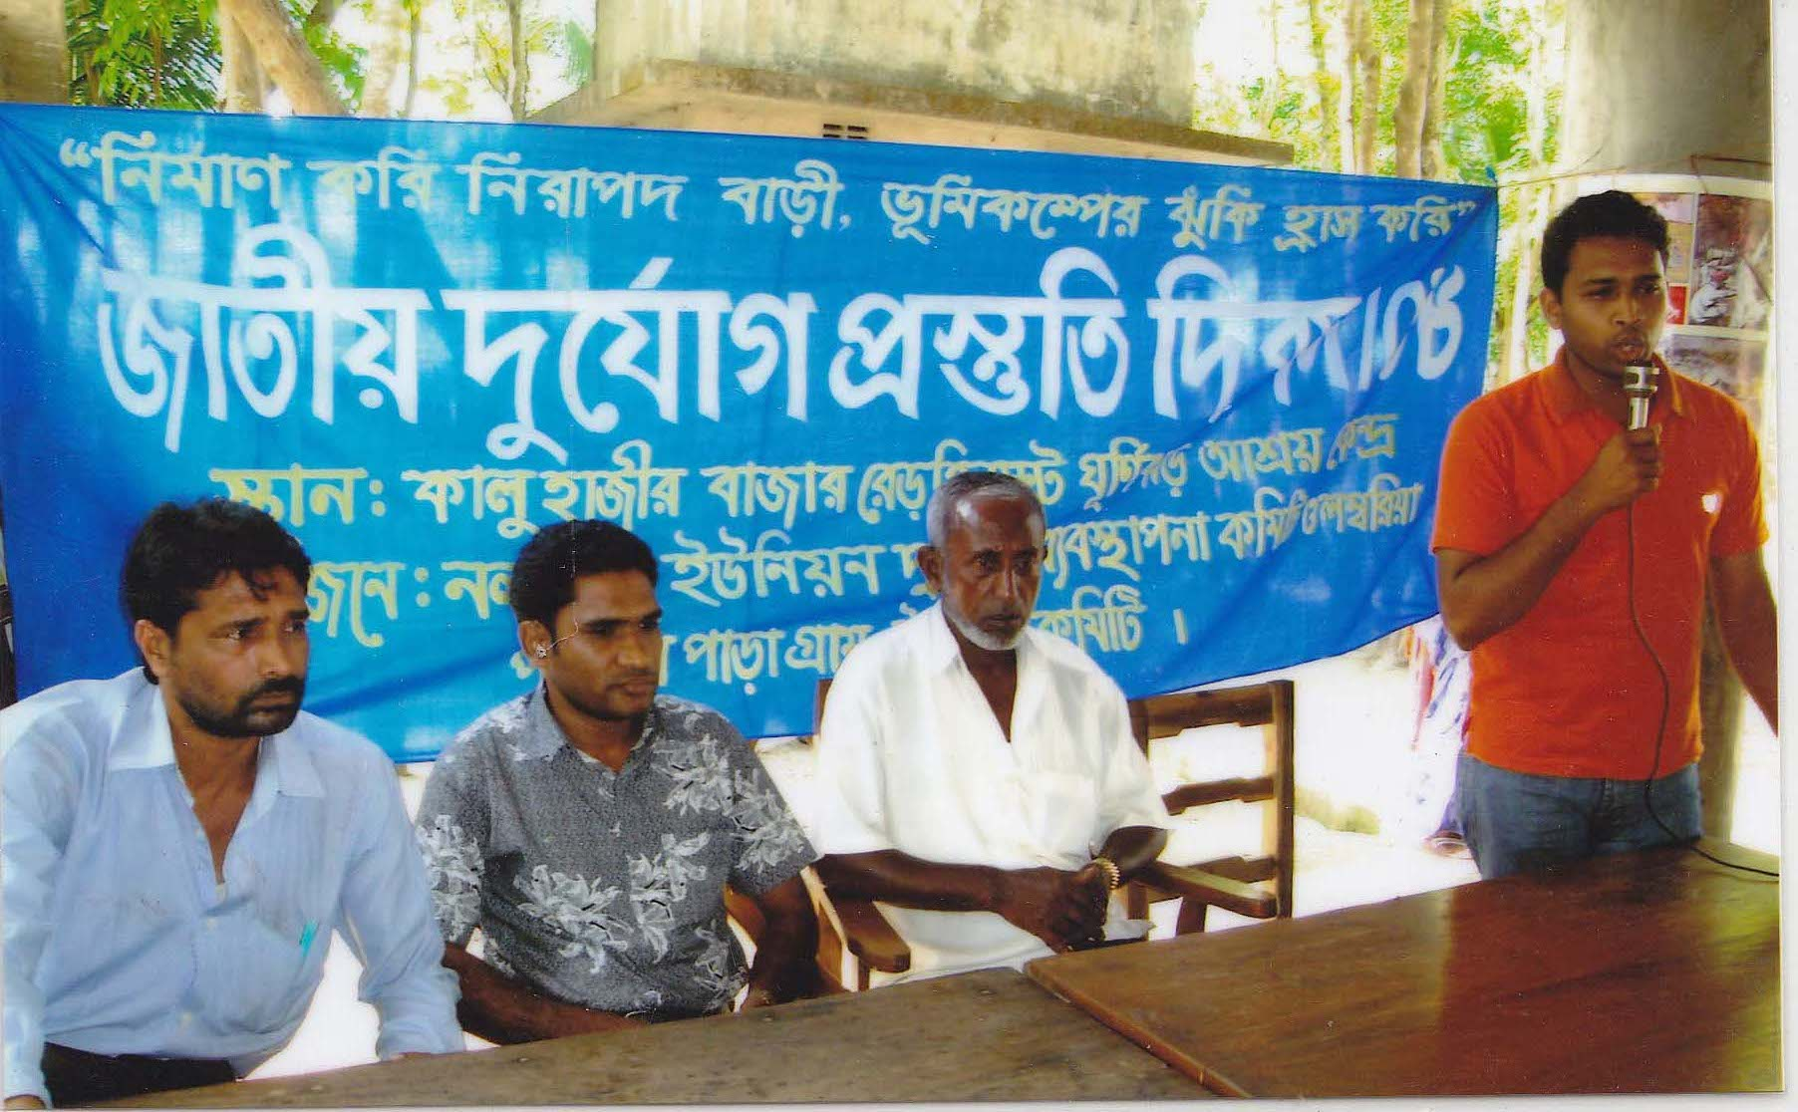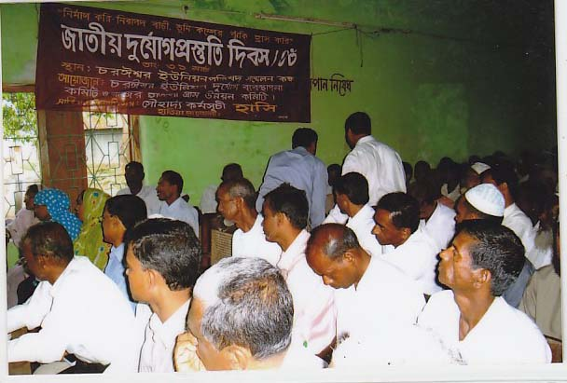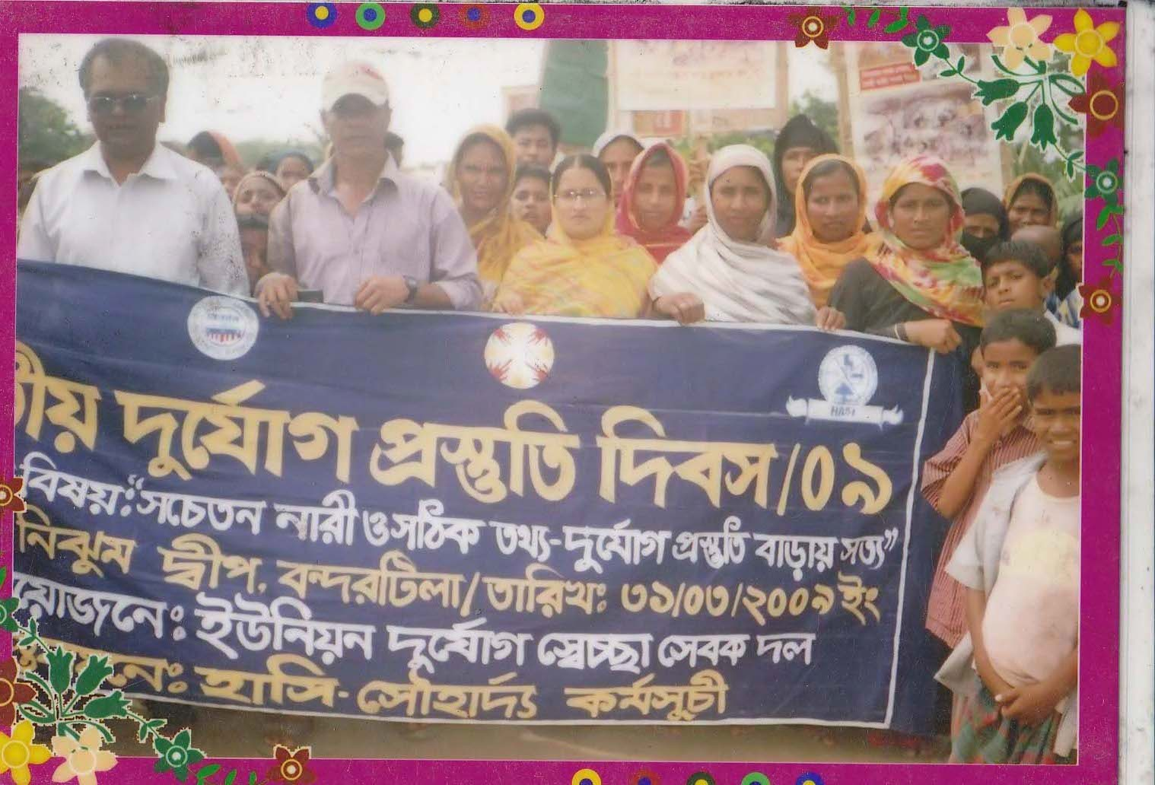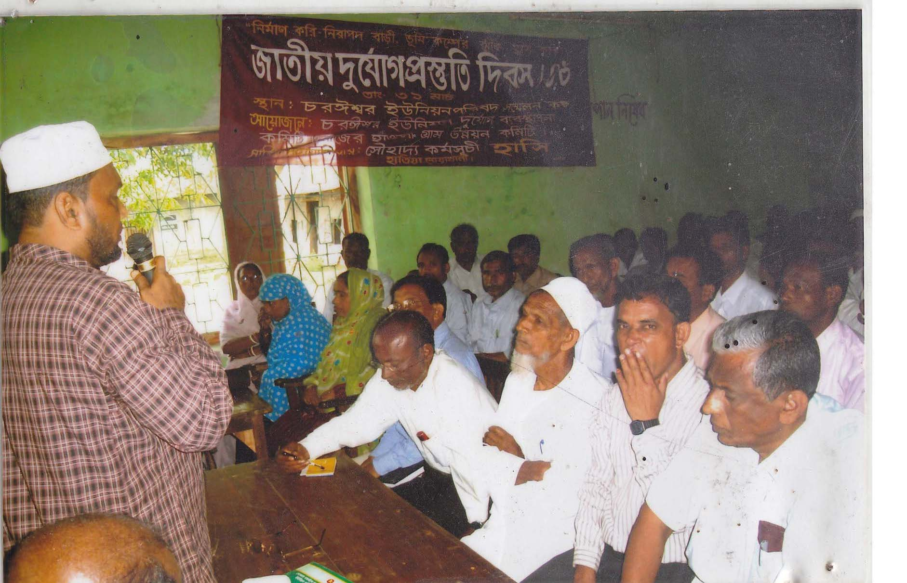
Community mobilization on Disaster Preparedness

Name of the ongoing project and working strategy

Sl# | Name of the Project | Working Strategy
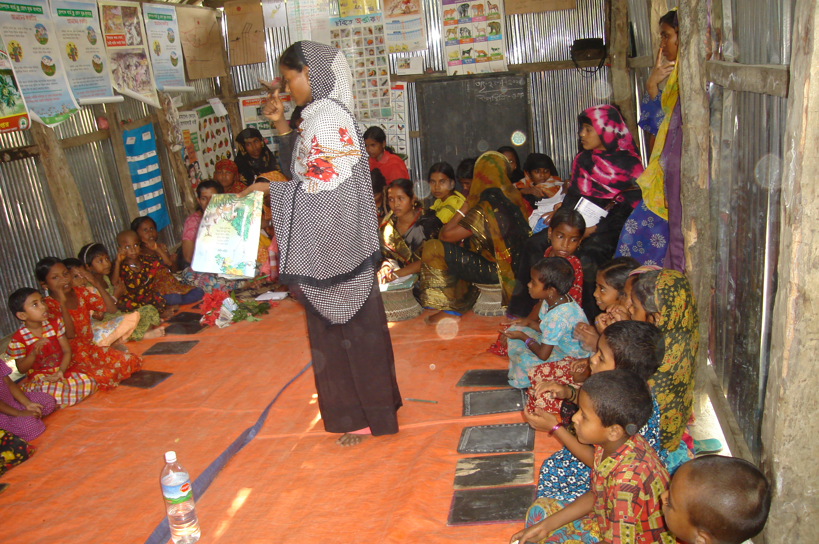  01 | Non Formal Primary  Education (NFPE) | Under an understanding of memorandum with BRAC-ESP, HASI has been working in NFPE sector since 1998 till to date HASI conducting 15 schools with 450 Learners through participatory Learning facilitation at the age group 5+ to 11+ those who are living in the outreach area from Govt. & Non Govt. Institution or organization.
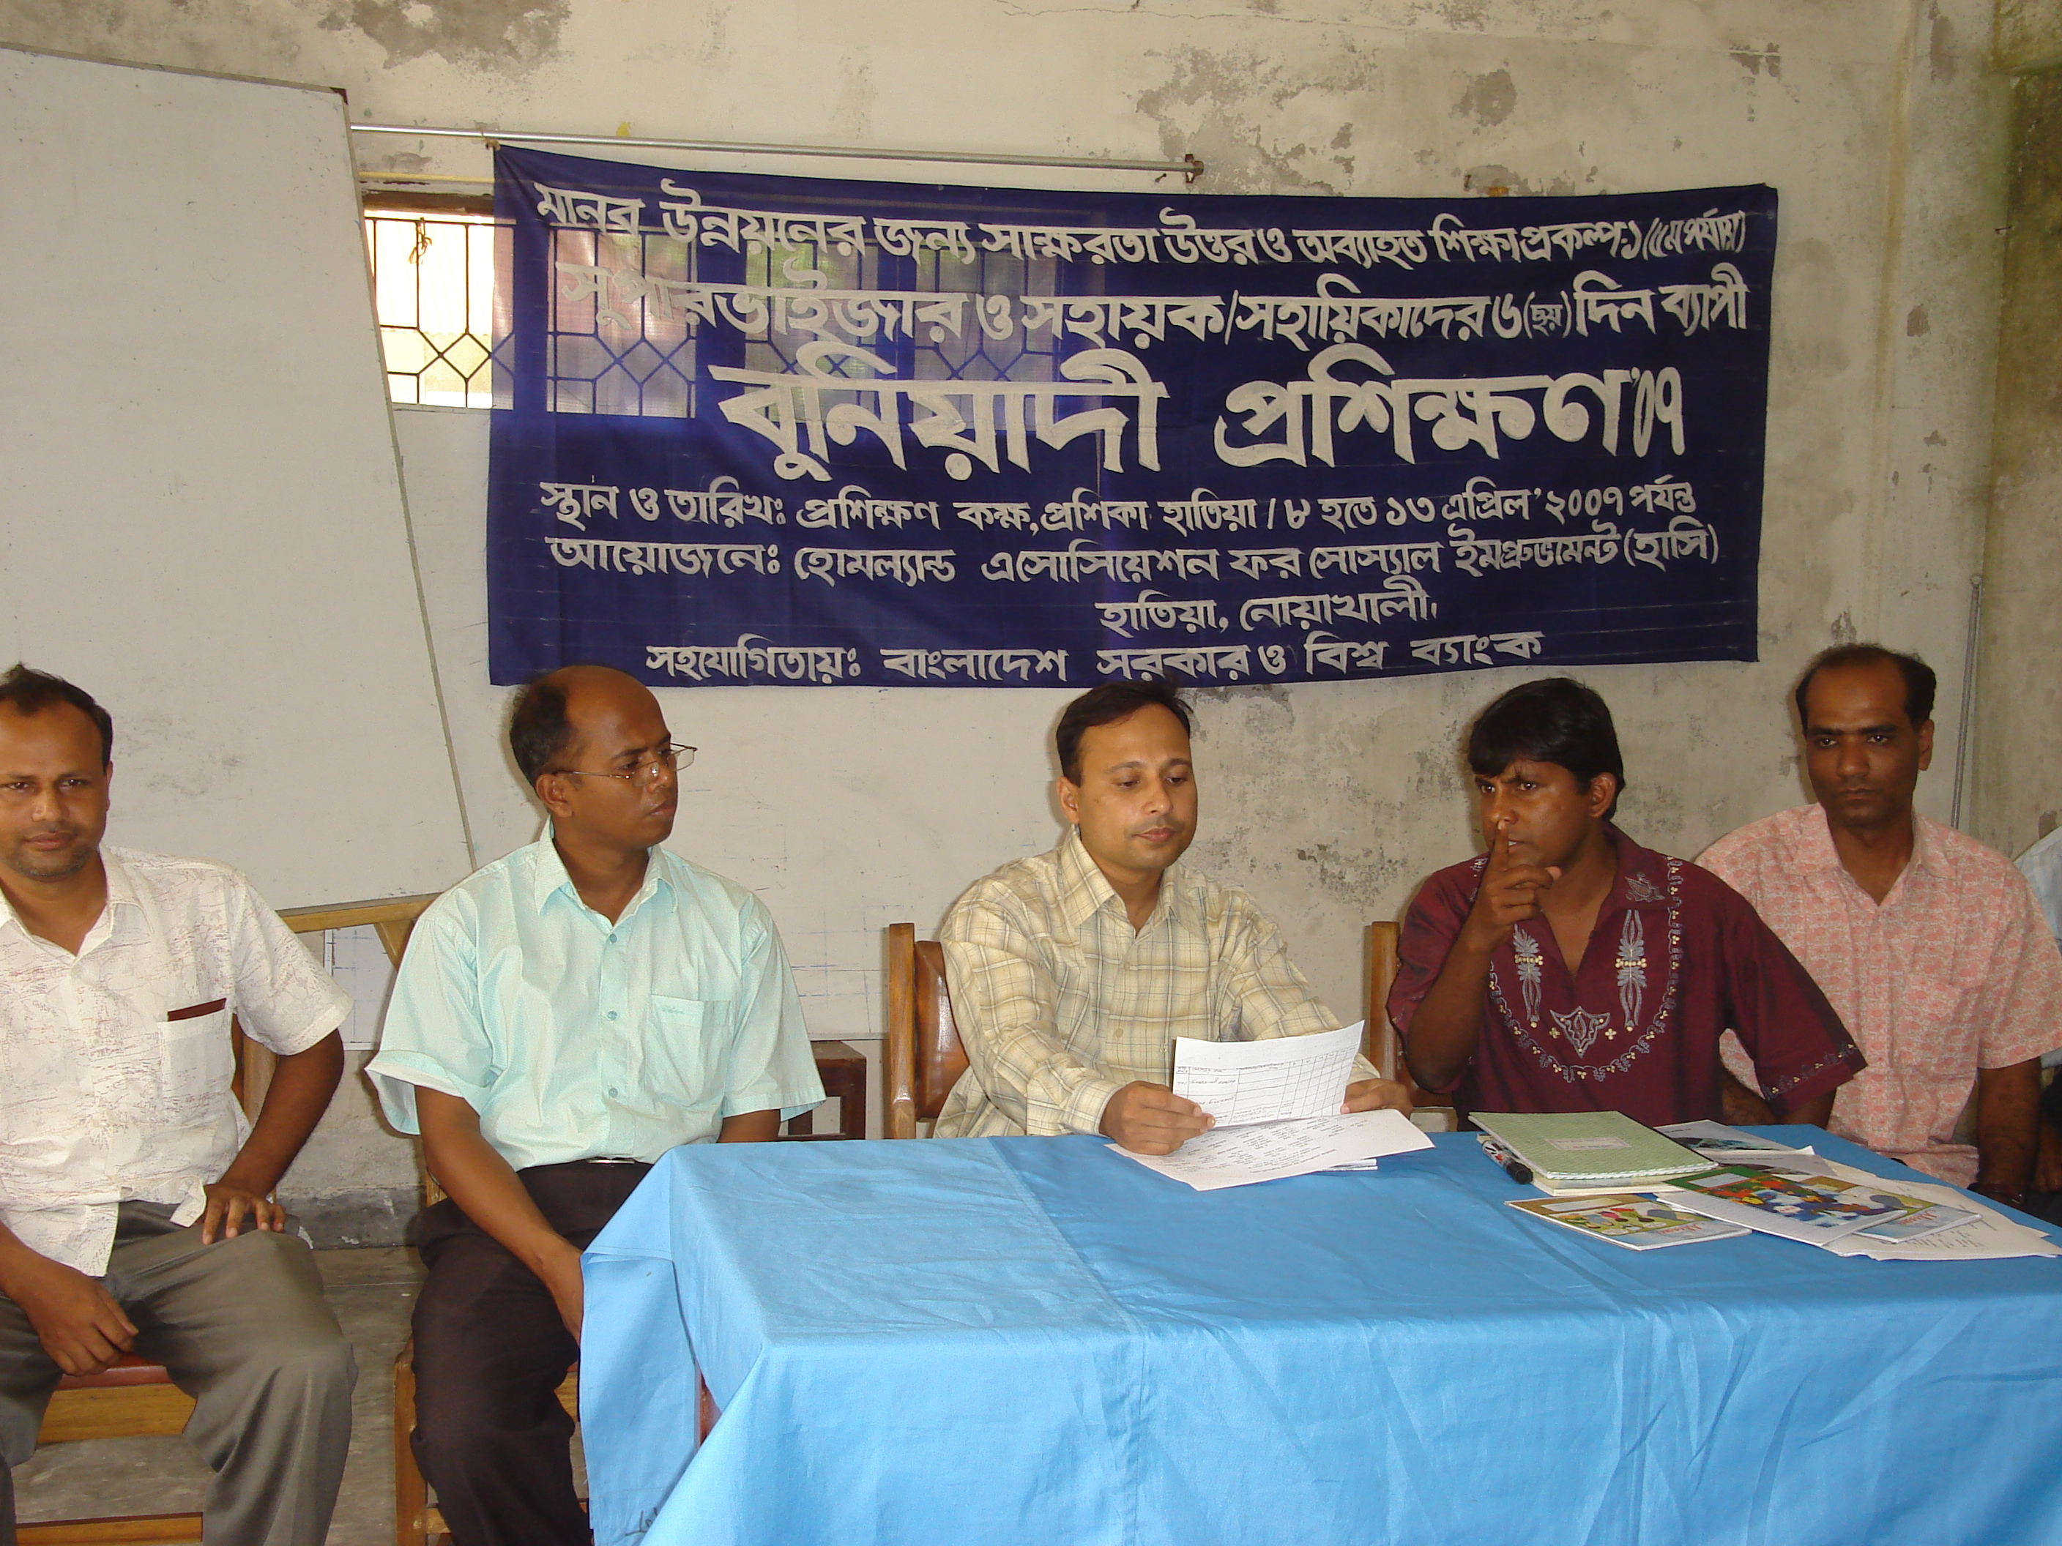  02 | Post Literacy and continuing  Education for Human  Development Project  (PLCEHD-1) | With the major Assistant from PLCEHD-1 HASI organize 30 (Thirty) Center (Double Shift). One shift is operated with (Thirty) 30 Women learners & another shift is 30 (Thirty) male Learners through a Center. There are two courses in a shift. One is PL e.g post Literacy and another is CE (Continuing Education). PL is only for strengthening Literacy Status & CE is Completely Technical course. There are two Facilitators conduct the center from PL to CE. After completing PL two technical people are recruited to conduct the CE course.

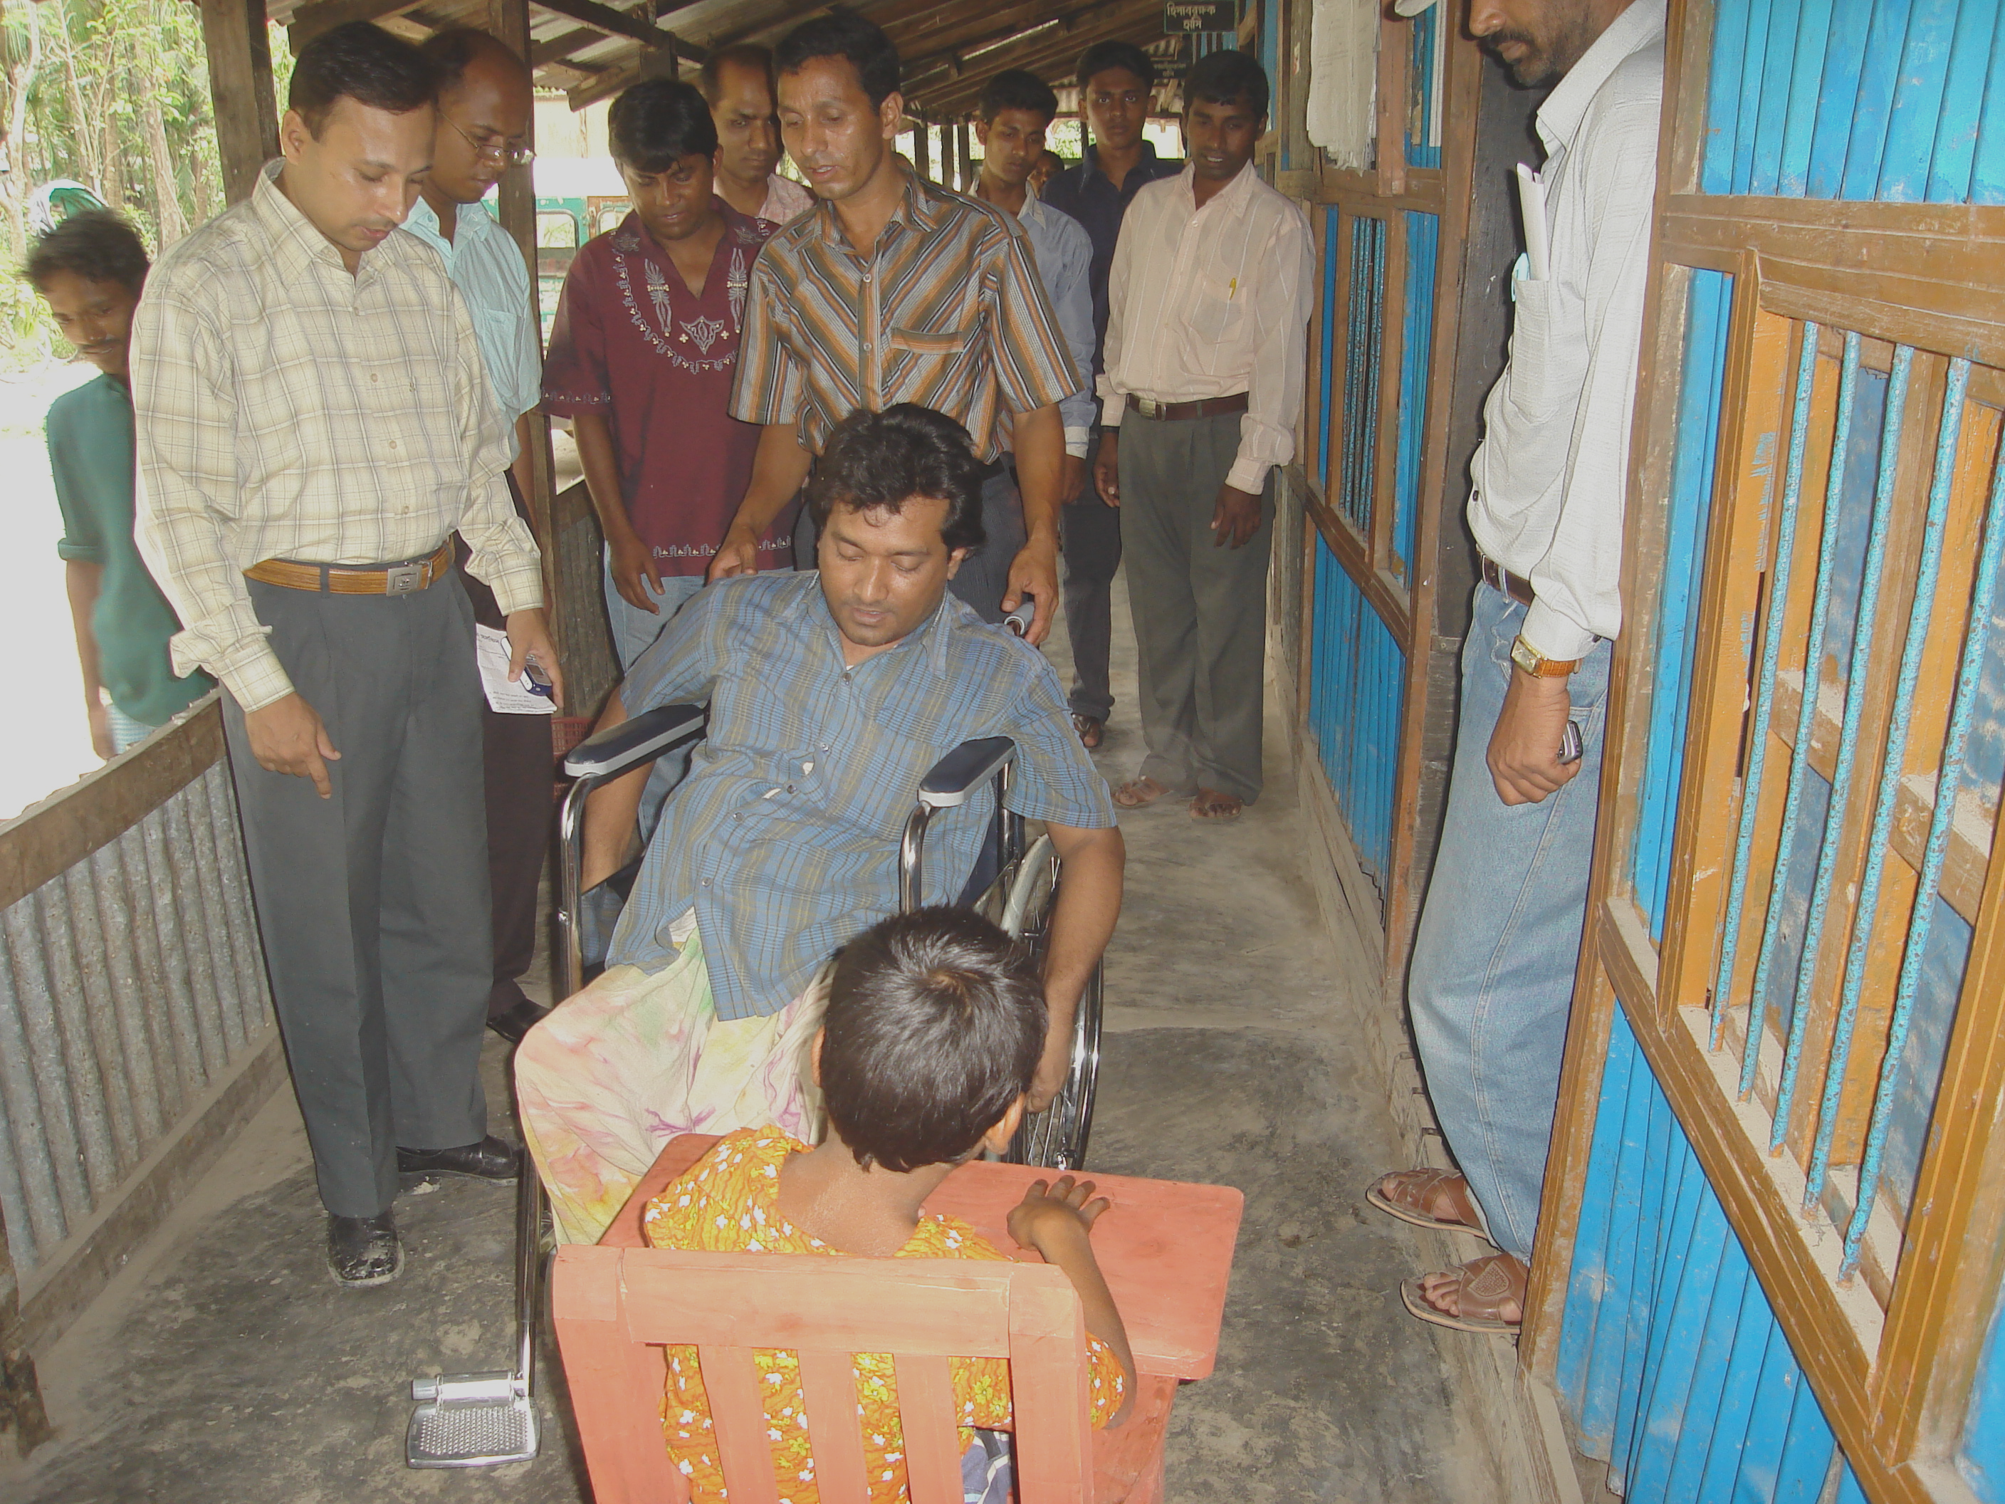  03 | Community Based  Rehabilitation for PWDs | HASI has been working with the persons with a disability since its inception. HASI has two CHDRP (Community Handicap & Disability Resource person) The work among the 60 (sixty) PWDs through community based rehabilitation program they also provide some doorstep services like PRT (Primary rehabilitation Therapy), Referral service, inclusive Education & Credit support for IGA, HASI Trying its best to brings the PWDs to main stream of development.
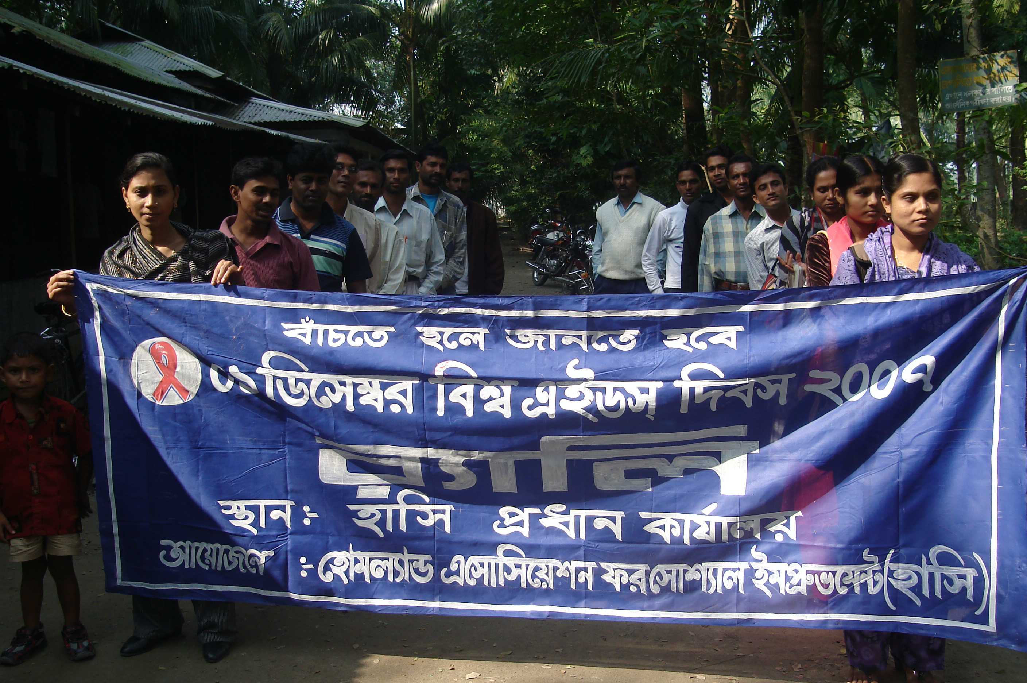  04 | Water Sanitation and Health & HIV/AIDS Project | Partnership with MOH&FP, NGO- Forum and Providing support to implement NID specially establish VSC and Produce ring slab for highly risked people as sanitary concern.  awareness raising camping with HIV/ AIDS risked community
05 | 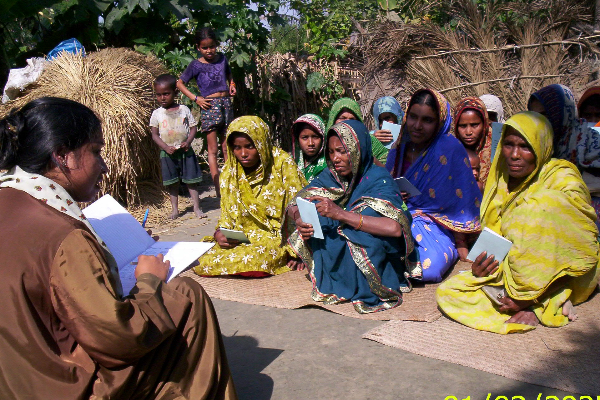  Micro Credit for Poverty Reduction | For the poverty reduction of poor people at the rural level by formed group and making aware the groups for the social condition.
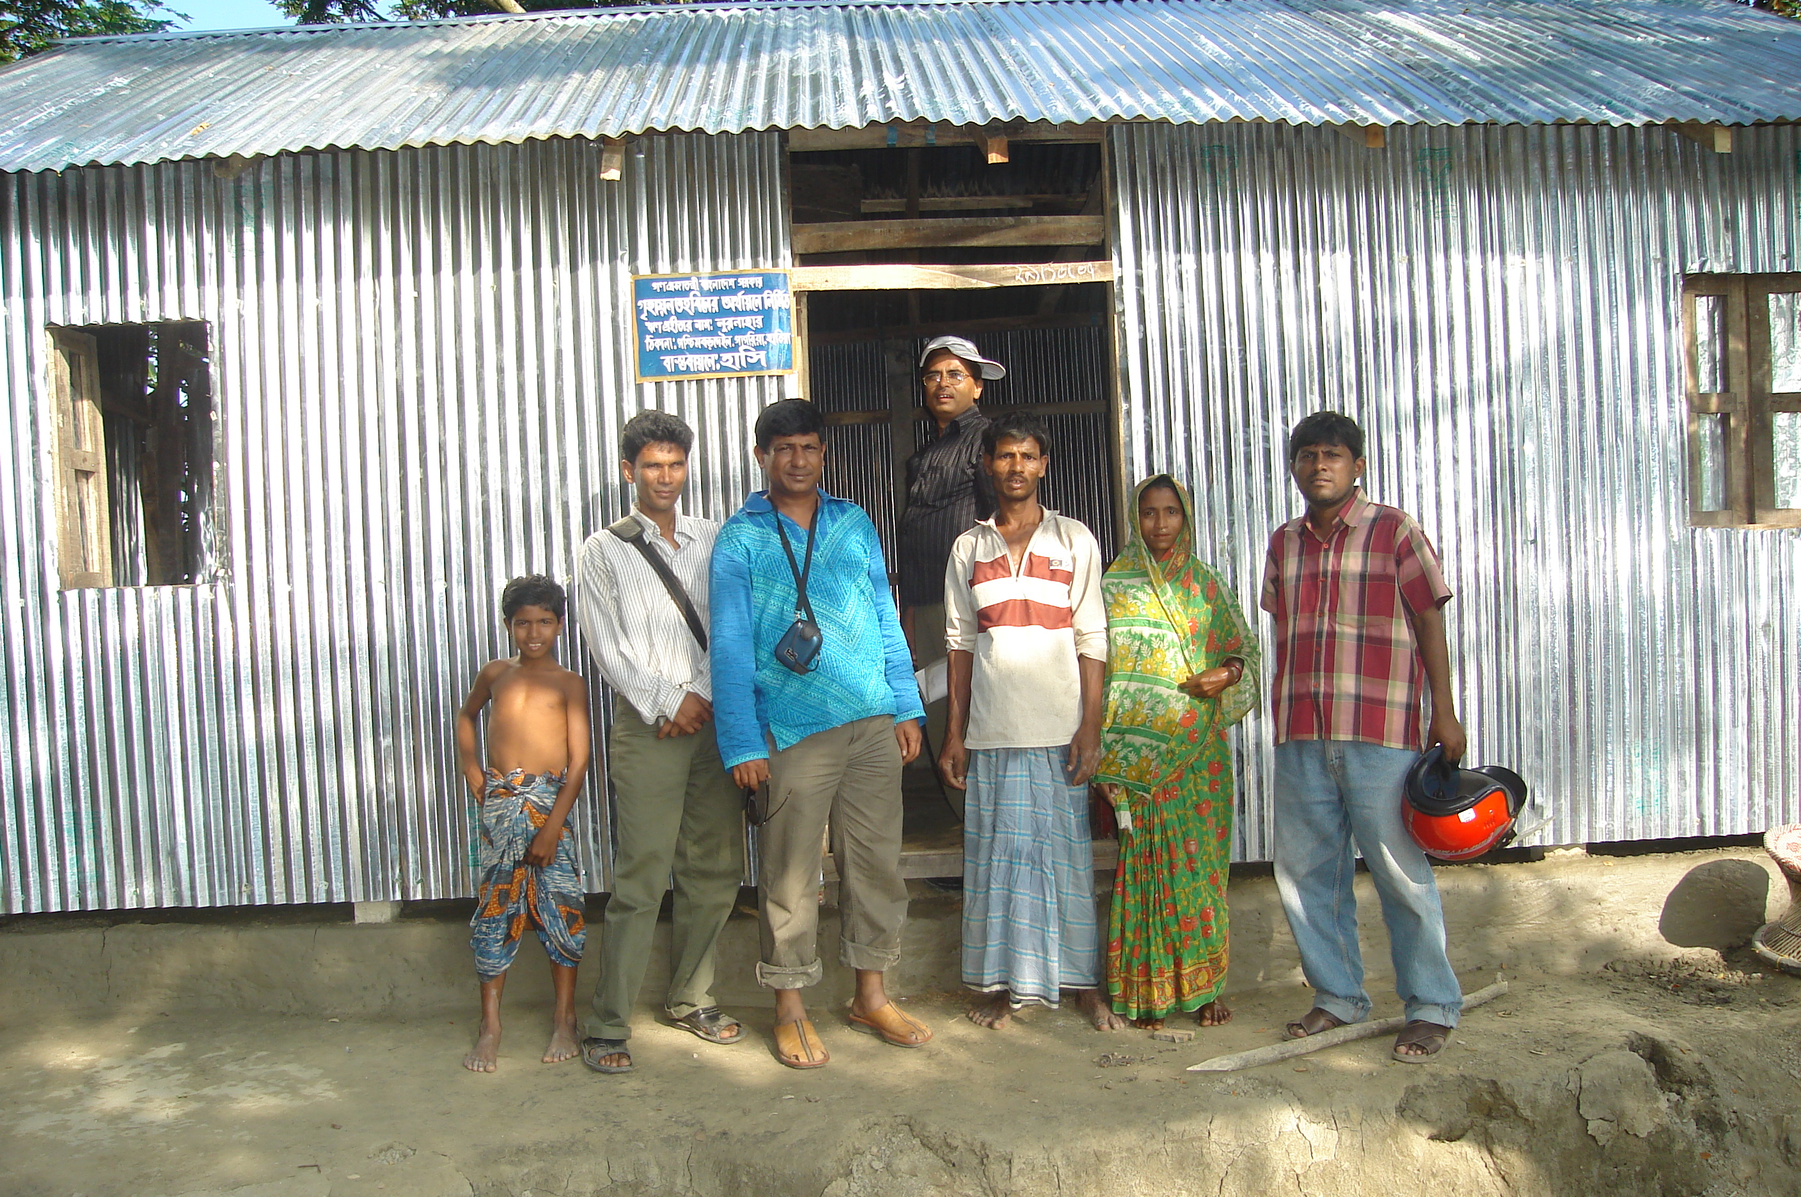  06 | Rural Housing Loan Program | HASI has been selected the pro poor who are home less and provided them housing support to secure their livelihood.

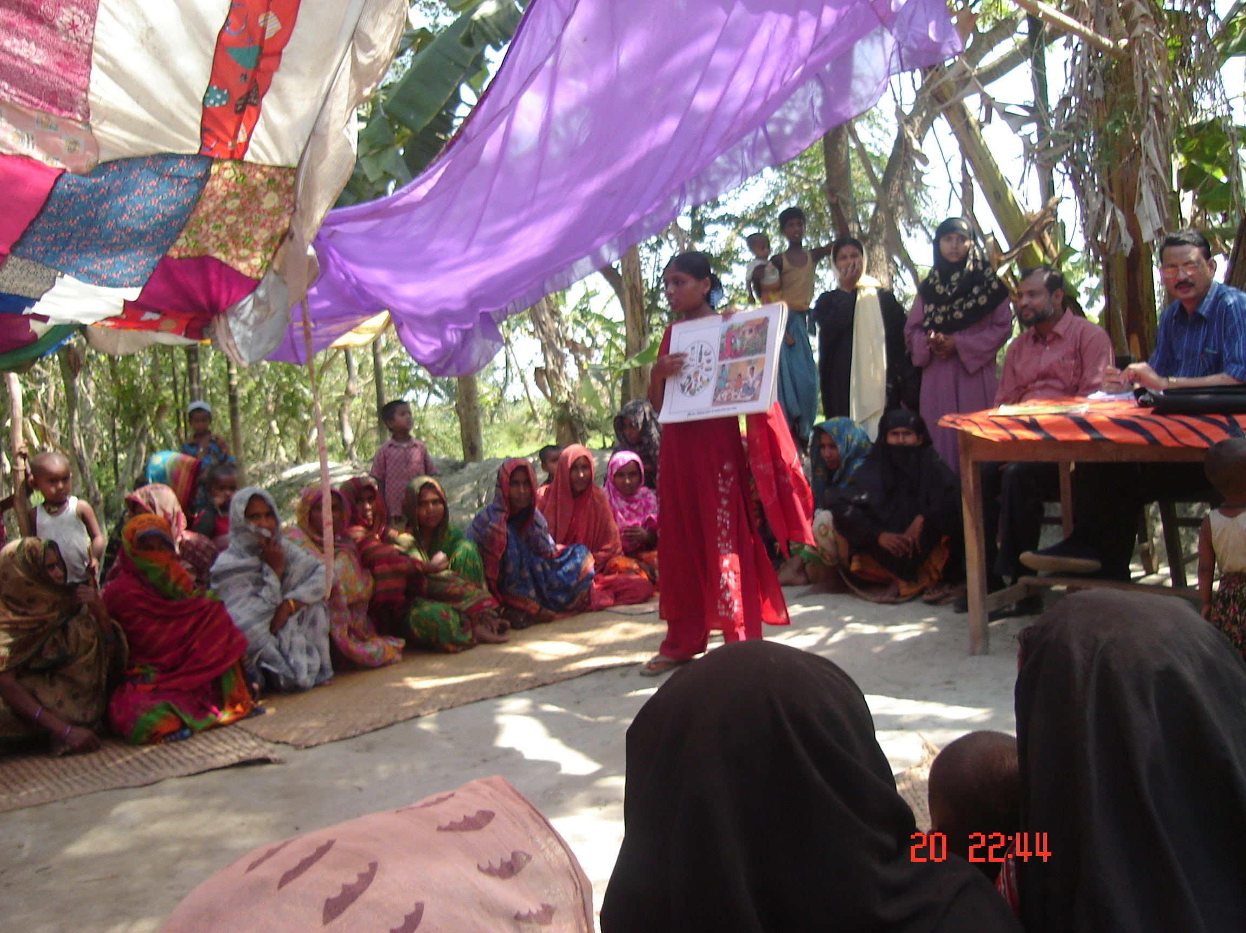  07 | Char Development and Settle-ment Project-III (CDSP-III) | Total New char settler of the Boyerchar were included in CDSP-III Program & having their  well being through community consultation. Capacity Building of beneficiaries are provided all of the targeted people. It is fully implemented through different types of training like group formation &savings management, Nursery development training, poultry & livestock training  disaster management training etc .
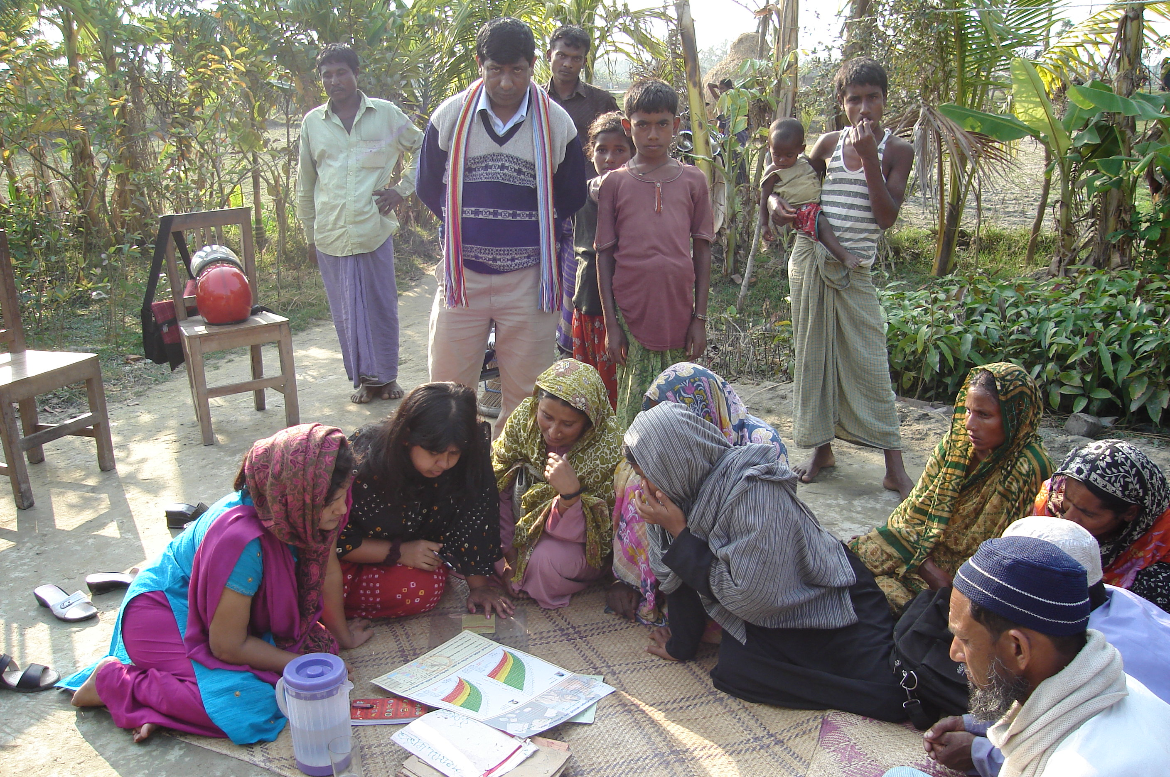  08 | HASI- SHOUHARDO Program | With the partnership of care- Bangladesh, funded by USAID, HASI has been implementing SHOUHADO program with close assistance of village development committee. It is completely community led approach program. Every community should do their community action plan based on CRA and implementation it through community led process and undertake their own risk reduction plan.
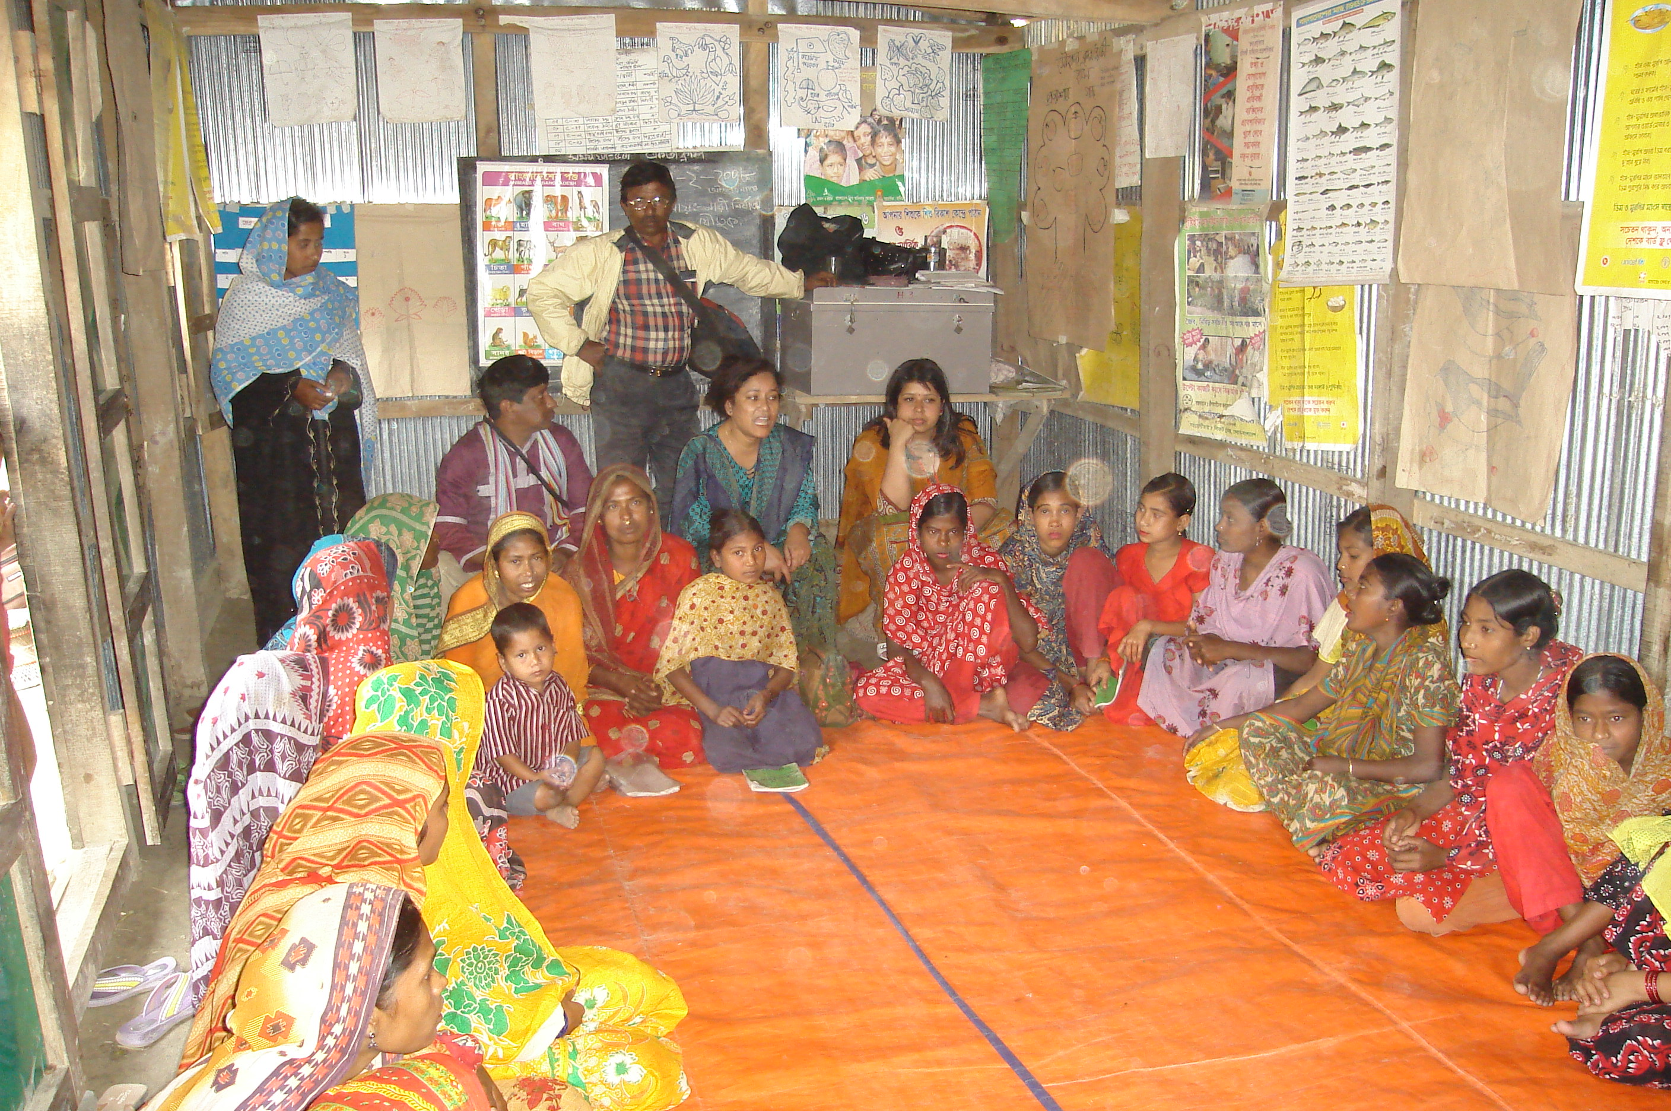  09 | HASI- KISHOREE SANGLAP Program | By the financial support of CODEC, HASI Introduce Kishoree Sanglap Program for Empowering Adolescent girls operating Kishoree Sanglap Centre Through dialogue Session With the Adolescent and their awareness building on DRR to put them in action for further and wider dissemination of awareness messages

Major activities of the project (Project wise)

Name of the project | Main Activities
Non Formal Primary Education  (NFPE) | - Teacher Selection/ Recruitment  - Teacher Training conduct  - Baseline Survey.  - Formation of Center / School management Committee.  - Motivational Meeting/Counseling.  - Learner’s selection.  - Center/ School operation.  - Organized Cultural Program.  - Follow-up.  - Monitoring.  - Reporting.
Post Literacy and continuing  Education for Human Development  Project (PLCEHD-1) | - Teacher Selection/Recruitment  - Teacher Training conduct  - Baseline Survey.  - Formation of Center/ School  Management Committee.  - Motivational Meeting/ Counseling.  - Learner’s selection.  - Issue Based Training  - Organized Cultural Program.  - Follow-up.  - Monitoring.  - Reporting.

Water Sanitation and Health &  HIV/AIDS Project | - Awareness Rising for HIV/AIDS  - Training  - Counseling  - Social Mobilization  - Social Mapping  - Survey  - Health education  - IEC materials distribution.  - Demonstration  - VSC operation  - Installation of water sealed latrine  - Installation of tube wells  - Awareness rising on Arsenic
Micro Credit for Poverty  Reduction | - Baseline survey  - Area Selection  - Awareness Rising  - Group Formation  - Weekly Group meeting & Discussion about Development Issues  - Saving Collection  - Skill Training to the Group Member for IGA Selection  - Feasibility study for IGA selection  - Need based Training  - Credit Disbursement for IGA  - Credit Realization & Follow-up

Community Based Rehabilitation  for PWDs | - Community survey.  - Early detection and intervention.  - Social mobilization.  - Community based participatory planning for Rehabilitation.  - Advocacy & lobbing for establishing equal Rights & opportunity for the PWDs  - Arrange Vocational Training for the Disable  - Primary Rehabilitation Therapy.  - Inclusive Education.  - Referral service.  - Credit for IGA.
Rural Housing Loan Program | - Base line survey.  - Area selection.  - Beneficiaries selection  - Credit Disbursement  - Sanitation Support
Char Development & Settlement Project-III (CDSP-III) | - Base line survey  - Staff Training  - Beneficiaries selection  - Training to Beneficiaries  - Group formation & Savings Management Program  - Polli Samaj Formation  - Health &Nutrition  - Social Forestry program  - Human Rights &Legal Services Program  - Disaster Management Program  - Homestead Crop cultivation Program  - Farmers forum  - Poultry &Livestock program
SHOUHARDO Program-HASI | - Base line survey  - Beneficiaries selection  - Staff Capacity Development/ Building  - Formation of Village Development  - Committee  - Formulation of Community Action Plan  - Intervention(Agriculture, Comprehensive Homestead Development, Fisheries,& Income Generating Activities) wise Training to Beneficiaries  - Mother & Child Health Nutrition Food Distribution  - Cash For Work (Small Infrastructure Development)  - Inputs Distribution  - Linkage Development  - Women empowerment  - Early Child care & development  - Advocacy on violence against women & khas land
HASI- KISHOREE SANGLAP Program | - Area Selection  - Animator Selection through proper process.  - Animators Basic Training.  - KISHOREE SANGLAP Centre mobilise  - SST Formation  - KISHOREE SANGLAP Centre opening.  - Material Collection For operating Centre  - Conducting Dialogue session  - Monthly Animators Refreshers

Targeted Beneficiaries number; female, male and children

Name of project | Female | Male | Children | Total
Non Formal Primary Education (NFPE) | - | - | 900 | 900
Post Literacy and continuing Education for Human Development Project (PLCE)-1 | 900 | 900 | - | 1800
Community development and Arsenic Mitigation Project | 4300 | 2900 | - | 7200
Community Based Rehabilitation for PWDs | 17 | 03 | 60 | 80
Greater Noakhali Aquaculture Extension Project (GNAEP) | 278 | 314 | - | 592
Water Sanitation and Heath & HIV/AIDS Project | 1268 | 1132 | - | 2400
Micro Credit for Poverty Reduction | 1559 | 176 | - | 1735
Rural Housing | 182 | 193 | - | 375
Horticulture & Nutrition Development Project for Islander (HNDPI) | 1000 | - | 70 | 1070
Char Development & Settlement Project | 1,700 | 200 | 150 | 2050
SHOUHARDO (USAID & CARE- Bangladesh) | 6296 | - | - | 6296
VGD | 3847 | - | - | 3847
Hysawa | 11200 | 1600 | - | 12800
Total | 32547 | 7418 | 1180 | 41145

Existing Partners (If any)

Name of the Organization | Nature of partnership |  | Remarks
Name of the Organization | Membership | Partnership | Remarks
Association of Development Agencies in Bangladesh (ADAB) | √
NGO Forum for Drinking Water Supply & Sanitation |  | √
Bangladesh Manobadhikar Samonnoy Parishad. | √
National Forum of Organization Working With the Disabled (NFOWD) | √
Bangladesh Shishu Adhikar Forum | √
Credit & Development Forum (CDF) | √
Gender Relation & Development Forum (GDF) | √
The Institute of Democratic Right (IDR) | √
STI / AIDS Network of Bangladesh | √
Federation of NGOs in Bangladesh (FNB) | √
Inter Life Bangladesh |  | √
BRAC |  | √
Center For Disability in Bangladesh |  | √
Comilla Noakhali Development Network |  | √
Noakhali NGO Coordinating Council | √
KOINANIA |  | √
Care- Bangladesh |  | √
PROSHIKA |  | √
OXFAM- Bangladesh |  | √
Khan Foundation | √
GNAEP-DANIDA |  | √

Name of the Ministry Affiliated

SI.# | Name of Project | Name of affiliated Ministry
1 | Non Formal Primary Education (NFPE)
2 | Post Literacy and continuing Education for Human Development Project (PLCE)-1 | Primary & Mass Education ministry
3 | Community Development and Arsenic Mitigation Project | Ministry of Local Government & Rural Development
4 | Community Based Rehabilitation for PWDs | Ministry of Social welfare
5 | Greater Noakhali Aquaculture Extension Project (GNAEP) | Ministry of Fisheries and Livestock
6 | Water Sanitation, Health and Nutrition Project | Ministry of Health of Family planning
7 | Micro Credit for poverty Reduction
8 | Rural Housing | Ministry of Finance
9 | Local Initiative for Farmers Training
10 | Char Development & Settlement Project | Ministry of Water Resource & 5 Ministry
11 | SHOUHARDO | Ministry of LGRD & C& 8 Ministry
12 | Hysawa Fund | Ministry of LGRD & C Ministry
13 | VGD | Ministry of Children & Woman Affairs

Name of the Donor funding their projects

SI.# | Name of Project | Name of affiliated Ministry
01 | Non Formal Primary Education (NFPE) | BRAC & Proshika
02 | Post Literacy and continuing Education for Human Development Project (PLCE)-1 | World Bank, SDC, and GOB
03 | Community Development and Arsenic Mitigation Project | World Bank, GOB
04 | Community Based Rehabilitation for PWDs | CDD, SK Netherland & GOB
05 | Greater Noakhali Aquaculture Extension Project (GNAEP) | DANIDA, GOB
06 | Water Sanitation, Health and Nutrition Project | NGO Forum and GOB
07 | Micro Credit for poverty Reduction | Proshika, CNDN and own fund
08 | Rural Housing | Bangladesh Bank-GOB
09 | Local Initiative for Farmers Training | CARE- Bangladesh
10 | Char Development & Settlement Project | Royal Netherlands Embassy & BRAC
11 | Regional Fisheries and livestock Development Component (RFLDC) | Ministry of Fisheries and livestock  & DANIDA
11 | Kishory Saglap | Stromme Foundation (Norway)& CODEC
12 | SHOUHARDO | USAID & CARE- Bangladesh
13 | Aila Rehab Project | USAID & CARE- Bangladesh
14 | Hysawa Fund | AUS AID, SDC, DANIDA & GoB
15 | VGD | GOB, SDC, AUS AID

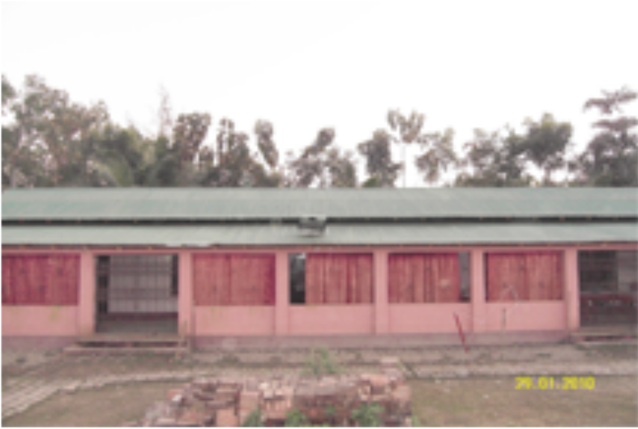

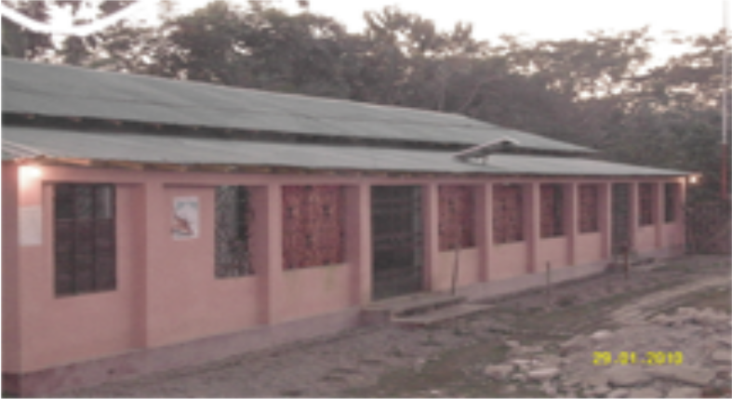

Training Center of HASI

List of assets properties of the organization

Sl. | Name of Equipment | Quantity | Year of Procurement | Status
01 | Steel Almira | 15 | 1996-2019 | Good Condition
02. | Computer & Printer | 5 set | 1998-2019 | Good Condition
03 | Motor Cycle | 13 | 2000-2018 | Good Condition
04 | Bi-cycle | 30 | 1996-2017 | Good Condition
05 | File Cabinet | 8 | 1996-2018 | Good Condition
06 | Chair with arm | 32 No. | 1996-2018 | Good Condition
07 | Chair without arm | 50 | 1996-2018 | Good Condition
08 | Secretariat Table | 22 | 1996-2018 | Good Condition
09 | Long Table | 10 | 1996-2015 | Good Condition
10 | Harmonium | 2 set | 1999-2008 | Workable
11 | Musical Drum | 1 set | 1999-2008 | Workable
12 | Bookshelf | 5 no | 2000-2019 | Workable
13 | Ceiling Fan | 20 | 1996-2018 | Good Condition
14 | Table Fan | 3 | 1996-2010 | Good Condition
15 | Camera | 2 | 1996-2020 | Good Condition
16 | Handy Video Camera | 1 | 1998-2008 | Good Condition
17 | Projector | 1 | 2020 | Good Condition
18 | Training center | 40 person | 2006 | Good Condition

